6.2.3 Implementation of e-Governance in Areas of Operation
Areas of Governance |  | Software | Name of the Vendor with Contact Details | Year of Implementation | Screenshot
ADMINISTRATION

A1. | Online Leave Application Software  Purpose: Used for applying casual leave online |  | Mr. Jagjit Bhatia  Mr. Rishabh Dhir  8146543791 | 2019 | 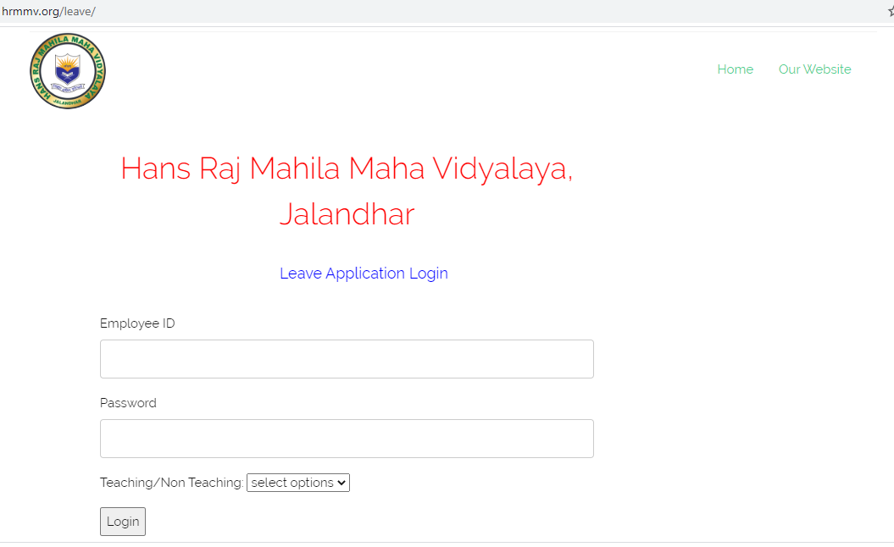
A2. | SMS Topguru.com  Purpose: Used for sending bulk messages to staff and students |  | ISoLS GurGaon  Mr. Ujjwal  9999888384 | 2019 | 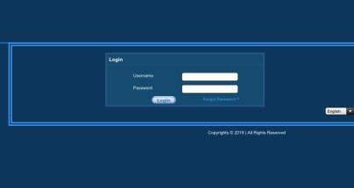
A3. | e-displays & e-notices  LG Signage  Purpose: Used for displaying e-notices to the students and staff |  | CT Infotech  Model Town, Jalandhar  0181-2274840 | 2018 | 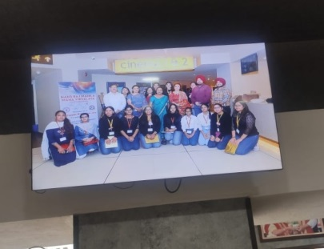
A4. | eSSLeTimeTracklite  (BioMetric)  Purpose: Used for the marking the Biometric of the staff |  | Mr. Jaswant  7696184112 | 2018 | 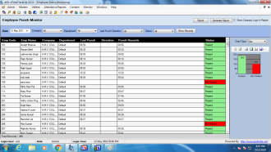
A5. | Website  www.hrmmv.org  Purpose: Used for displaying the college information |  | ISoLS GurGaon  Innovative Solution Technologies  Mr. Ujjwal Chugh  9999888384 |  | 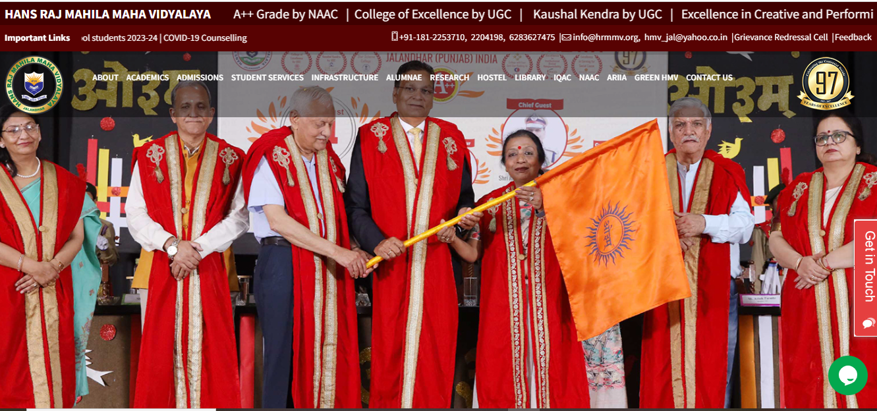
A6. | MS Office  Purpose: Used by the office staff to prepare the official documents |  | CTech Computers  Urban Estate Phase I, Jalandhar  0181-5053631 | 2015 | 
A7. | Designing Software  CorelDraw  Purpose: Used for designing Brochures, certificates, flex, etc. |  | Kraft Computers  Jalandhar  0181-2207348 | 2017 | 
A8. | Alice for Windows Web Pack Software & DELNET and N-List Facility  Purpose: Used for Library Management |  | Alice Softlink Pvt. Ltd., New Delhi  0129-2257872 | 2016 | 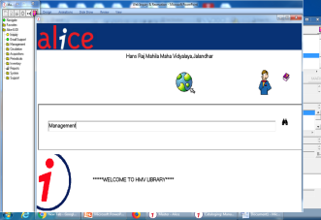
A9. | CCTV  Purpose: Used for the security purpose of staff and students |  | Parth Electronics  7888534345 | 2016 | 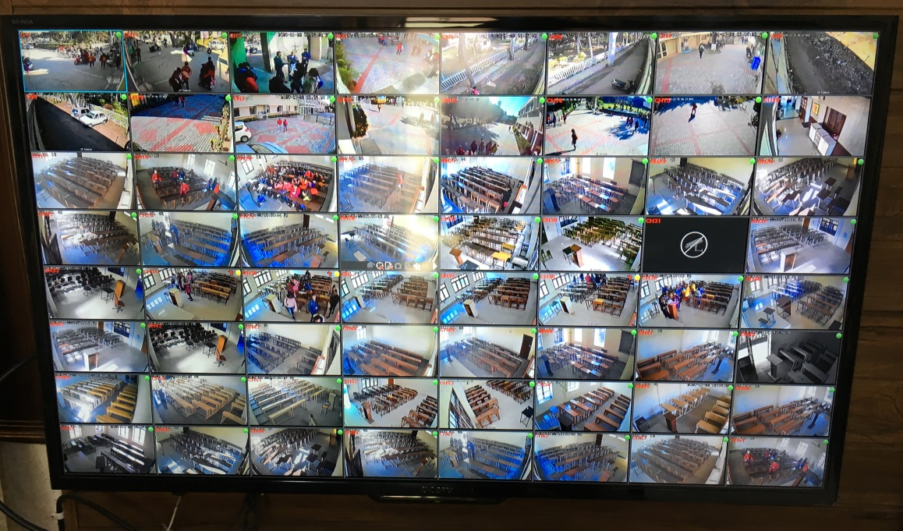
A10. | Adobe Photoshop  Purpose: Used for designing purpose with CorelDraw |  | Eurys InfoSystems Pvt. Ltd.  Noida  0120-4545055 | 2015  (Renewed in 2017) | 
A11. | IOS App for HMV News  Purpose: Used for displaying college activities in your devices |  | Ansh InfoTech, Ludhiana  9417168347 | 2015 | 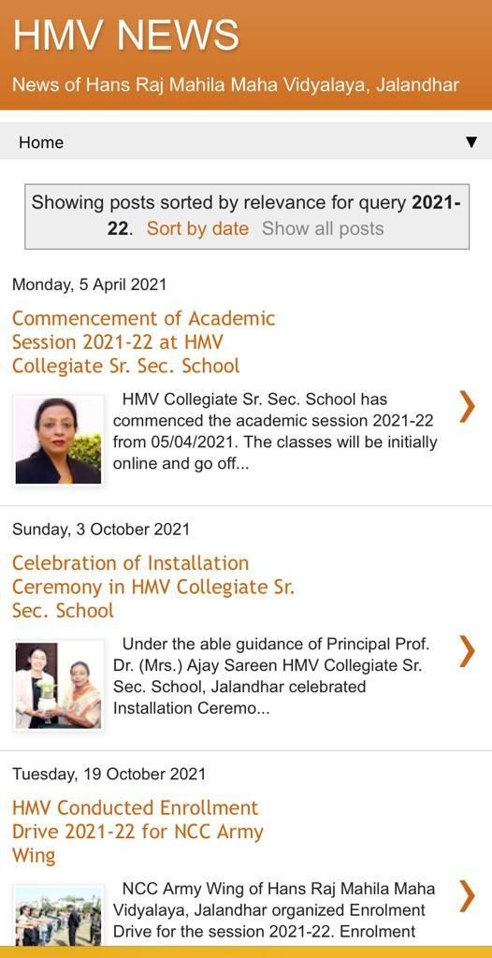
A12. | Whts App  Purpose: Used for sending e-notices to the staff and students |  |  | 2015 | 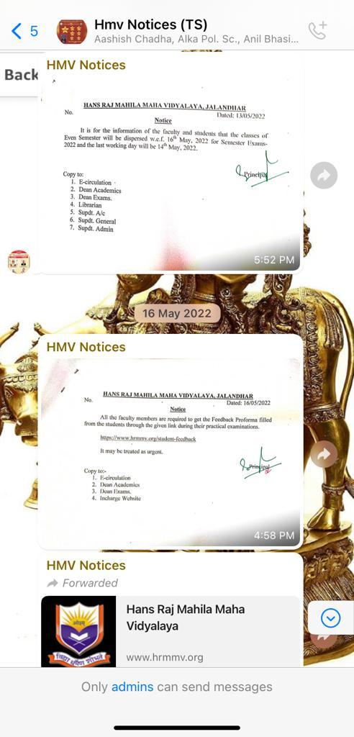
A13. | e-modules  (MS PowerPoint)  Purpose: Used for preparing e-modules by the teachers and to prepare presentations for official purpose |  | CTech Computers  Urban Estate Phase I, Jalandhar  0181-5053631 | 2017 | 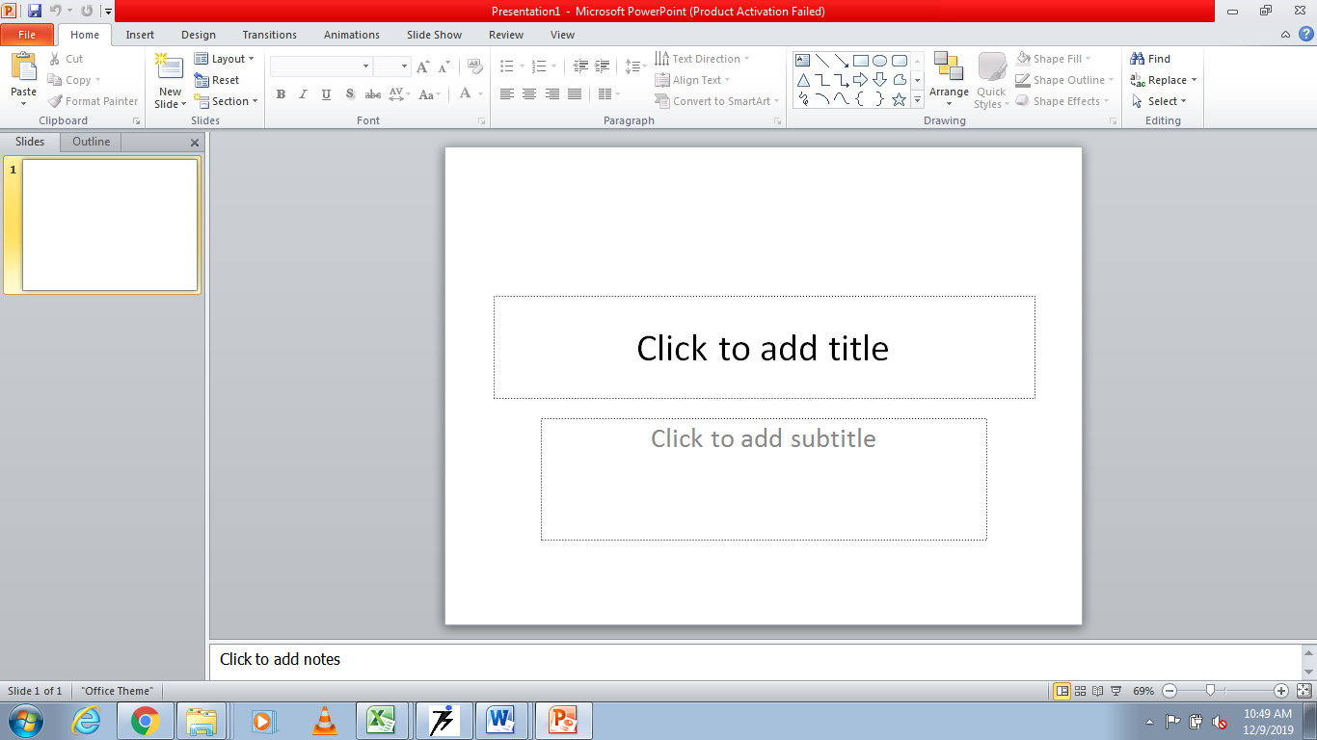
A14. | MS Excel  Timetable Software  Purpose: Used by the timetable committee for preparing timetables of the college |  | CTech Computers  Urban Estate Phase I, Jalandhar  0181-5053631 | 2015 | 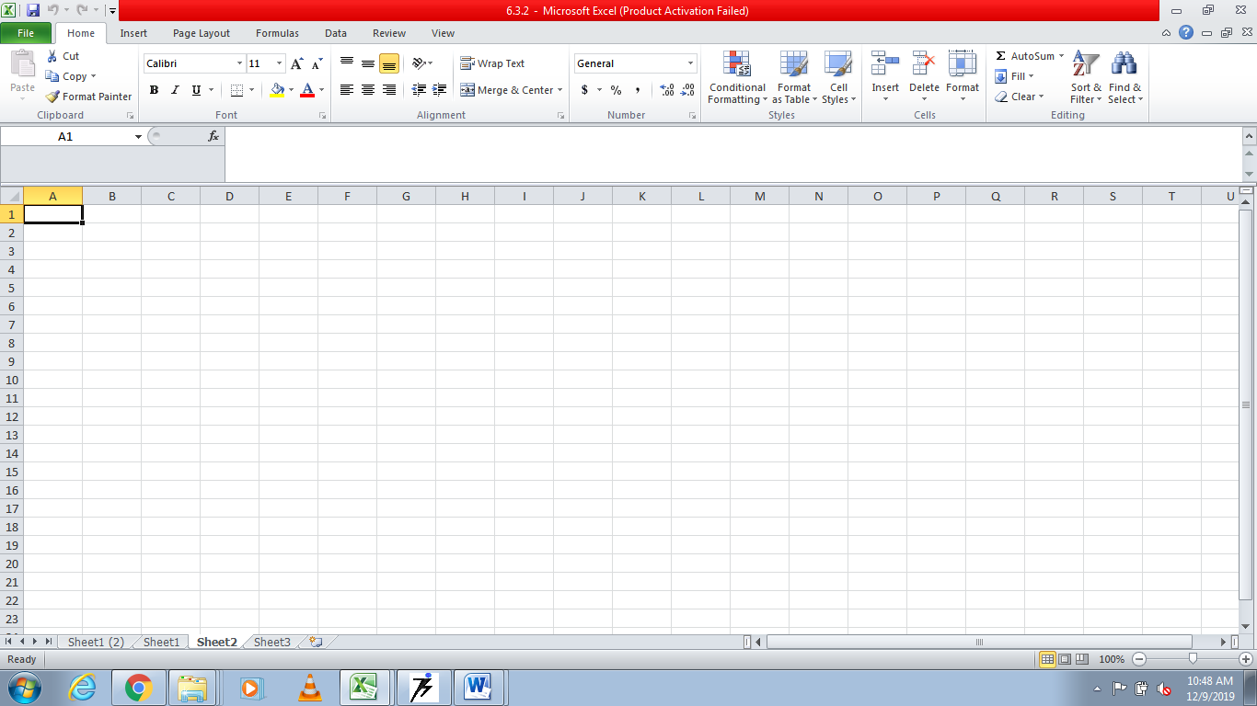
A15. | AutoDesk 3DS Max & AutoDesk Maya  Purpose: Used for the 3D modelling/designing purpose |  | Transtetore Globe (TG)  Shalabh.chauhan@hotmail.com | 2012 | 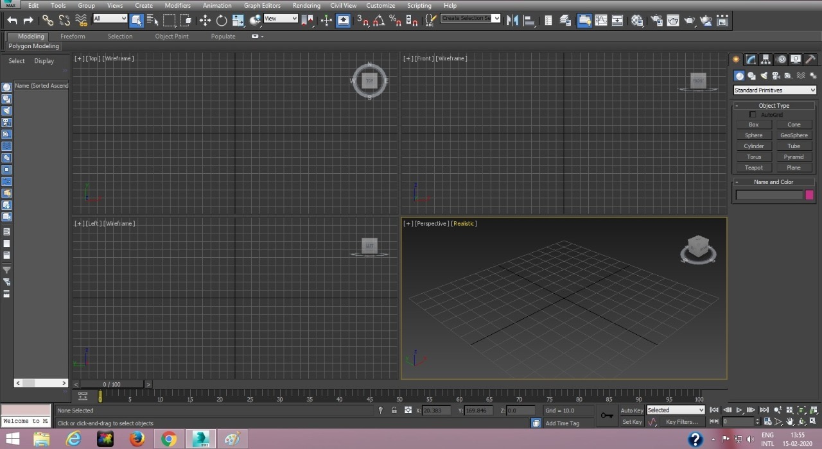  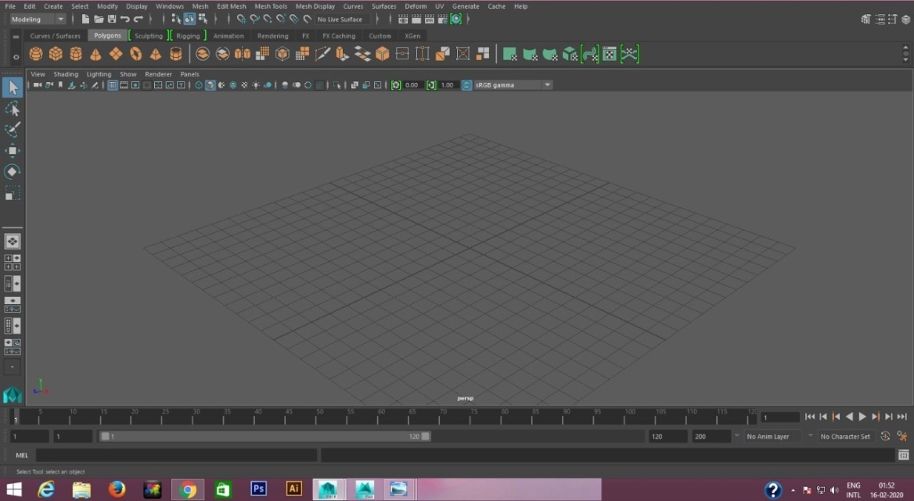
A16. | Leave Management Software  Purpose: Used by the office staff to mark leaves of the faculty, staff n students |  | Mr. Inderjit and Mrs. Sangeeta Bhandari  9872210032 | 2002 | 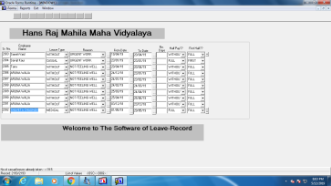
A17. | Communication Module (Higher Education)  Purpose: Used by the office for online correspondence with Managing Committee |  | DAVCMC | 2020 | 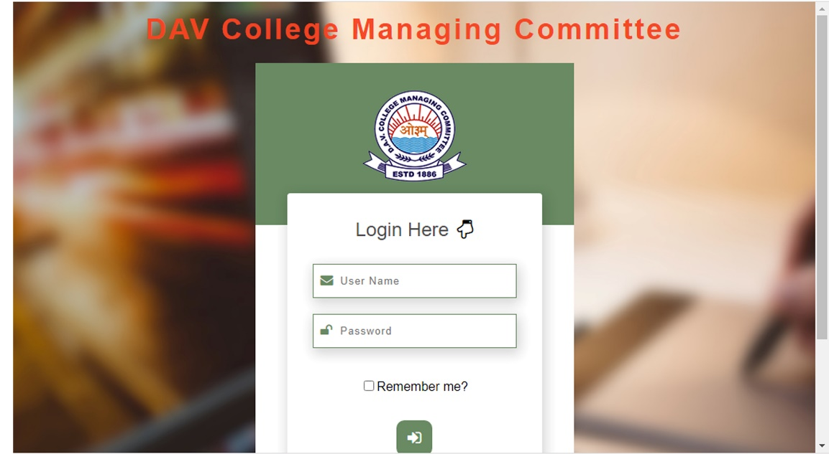
FINANCE AND ACCOUNTS

F1. | Fee Management Software  Purpose: Used to keep the track of the admission and university fee of the student. |  | BitField Solutions, Amritsar  Mr. Jatinder  9814593347 | 2017 | 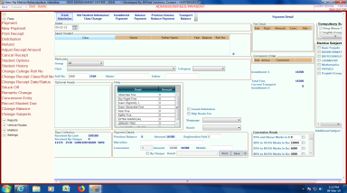
F2. | Hostel Admission and Mess Payment Software  Purpose: Used to keep the record of hostel admission and student’s mess payment. |  | BitField Solutions, Amritsar  Mr. Jatinder  9814593347 | 2017 | 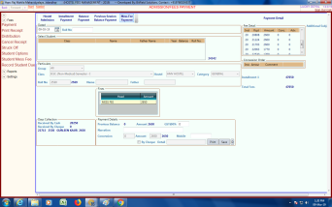
F3. | Transport Fee Management Software  Purpose: Used to manage the transport fee of the students according to their routes. |  | BitField Solutions, Amritsar  Mr. Jatinder  9814593347 | 2017 | 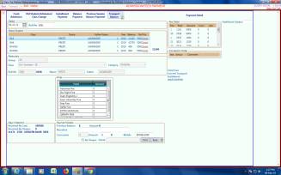
F4. | Visual Catpro Accounts  Purpose: Used for the accounts department of the college |  | Singh & Gupta  Catpro Software Services  0181-4600121  9872711228 | 2017 | 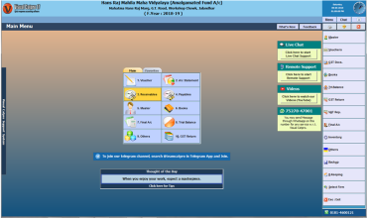
STUDENT ADMISSION AND SUPPORT

S1. | Student Scholarship Software  Purpose: Used to keep the record of all the scholarships given to the students. |  | BitField Solutions, Amritsar  Mr. Jatinder  9814593347 | 2017 | 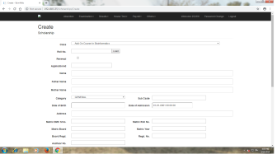
S2. | Online Absentee Software  Purpose: Used for marking the online attendance of the students |  | BitField Solutions, Amritsar  Mr. Jatinder  9814593347 | 2017 | 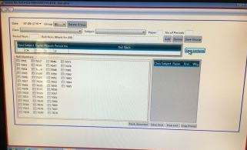
S3. | General Office & Management System  Purpose: This software is used for the management of tasks of general office like assigning roll number to the students, subject change information, university/board DMC entry, etc. |  | BSIM  BitField Solutions, Amritsar  Mr. Jatinder  9814593347 | 2018 | 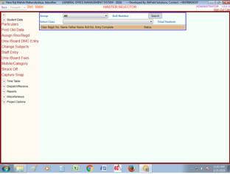
S4. | Bus GPS Software  Purpose: Used for tracking the college bus while picking and dropping the students |  | Conjonix  Mr. Umesh Chadha  9872435135 | 2016 | 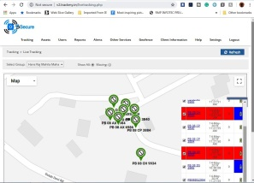
S4. | Learning Management System (LMS)  Purpose: Used for uploading e-modules and lesson plans for the purpose of students. |  | Mr. Jagjit Bhatia  8146543791 | 2019 | 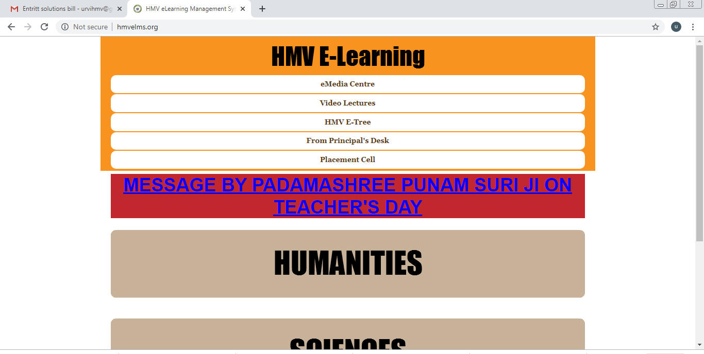
EXAMINATION

E1. | BSIM S/w for House Examinations & Results  Purpose: Used for entering MST result of the students. It also prepares the result card of students. |  | BitFields Solutions, Amritsar  9814593347 | 2018 | 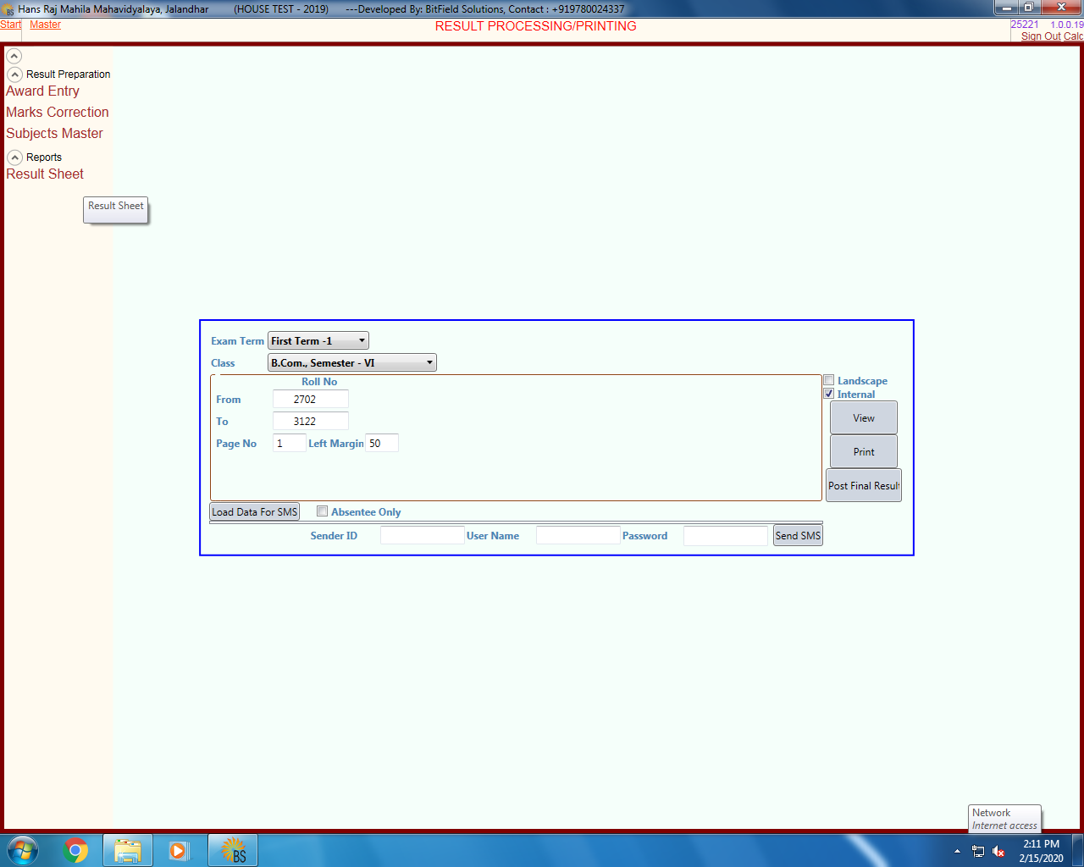
E2. | Online Student Return & Exam Portal (College Login Admission portal) |  | GNDU Amritsar | 2016 | 